Book Review

Nieto, S., & Bode, P. (2013). Affirming Diversity: The Sociopolitical Context of Multicultural Education (Sixth Edition). United States: Pearson Education. 450 pp., ISBN: 978-0-13-136734-0.

Reviewed by Rafet Günay, Curriculum and Instruction, Yildiz Technical University, Turkey.

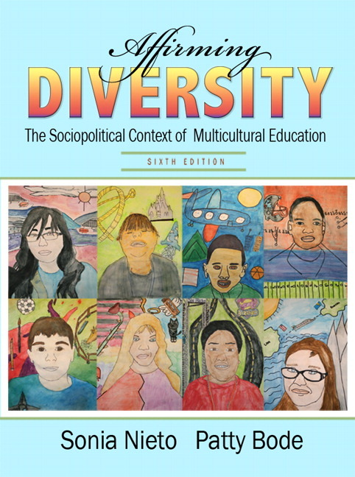
In this book whose topics are affirming diversity and equity in multucultural education, reasons and discussions of students’ success or failure are examined in a sociopolitical context through racial attitudes and linguistic issues. Also, the book not only focuses on students’ individual experiences and psycological conditions, but also makes some suggestions to educators about how social and educational structures and practices take place. In addition to this, it mentions that multicultural education should not only be taken into consideration at schools, but also in social, economic and political context of our world.
In the last twenty years, public schools and charter schools have gotten into market. Therefore, education has started to appear in both inside and outside the school atmosphere. However, it is clearly seen that there are differences in each stage of the state. For instance, election of an anit-racist president in the U.S.A., wars in Iraq and Afghanistan, election of a Latin woman judge in high court of justice in the U.S.A. for the first time… In the book, it has been mentioned that students from different ethnic backgrounds should have the awareness of multicultural education’s necessity and benefit to affirm different cultures. At that point, the effects of the sociopolitical condition of society and schools on learning and schooling have been researched in terms of affirming different cultures. Moreover, some other issues’ effects on learning - such as racism, bias, students’ expectations of success, school organization, education policies and practices, culture and ethnic, race, gender, language, sexual tendency, social and religious class - have been discussed in the book.
The book consists of ten chapters and in the first chapter, sociopolitical context of schools has been researched. In this chapter, key words, targets and assumptions of multicultural education have been defined. It has been pointed out that understanding multicultural education in a sociopolitical context has five tasks. These are, classifying keys words and aims of multicultural education, analyzing the myhtologies about migration and differences, naming social, economic, political and ideological foundations that have an effect on educational structures, examining demographic structure of society, cleansing national curriculum and policies from political challenges.
In the second chapter, multicultural education has been defined and the necessity of school reform has been mentioned. The author defines multicultural education and tries to explain school reform based on seven main characteristics. These are seven main characteristics; i) multicultural education is against racism. ii) Multicultural education is a main education. iii) Multicultural education is important for all students. iv) Multicultural education has mixed everywhere. v) Multicultural education is for social justice. vi) Multicultural education is a process. vii) Multicultural education is a critical pedagogy.
In the third chapter, the effects of racism, bias and discrimination on students’ success have been researched. By pointing out, gender, ethnic groups, social class, language, sexual tendencies, age, anti-semiticism, anti-Arabic discriminations, historical background of these biases have been examined. Moreover, it has been pointed out that according to a research about racism held in Stanford University which had 2300 participants, families whose socio-economic condition is low have more discrimination than others. Also, after the Hurricane Katrina (2005), a lot of families lost their home. For that reason, it has been mentioned that when the citizens who treated Afro-Americans appeared in the news, Americans got more unified.
In the fourth chapter, John Dewey’s saying “Democracy is not a place where you tell your own culture and traditions to get better.” has been focused and pointed out the necessity of a classroom atmosphere where different identities are taken into consideration although there are some political practices. It has also been mentioned that it is necessary to follow a students from each group and encourage them to attend activities inside the school. Furthermore, it has been said that the school curriculum should be organized that way and there should be an appropriate classroom atmosphere. It has also been mentioned that while organizing such a classroom atmosphere, it is necessary to take support from parents, teachers and students.
In the fifth and sixth chapters, there is a focus on the information about students’ identity, culture and learning and linguistic differences in classes in the USA. Also, it has been mentioned that there should be an equal status for all students to develop an attitude based on cooperation in a democratic environment.
In the seventh chapter, the focus is on understanding students’ learning and their success at school. There are also some theories on how to increase students’ academic success. These are caring, deficit perspectives, economic reproduction, cultural incompabilities, out of school factors, resistance, the school of prison pipeline, cultural ecological theories and complicating theories of identities within school structures. In the eighth chapter, the authors try to define the condition of suppportive teachers and schools that help students to be successful. It has been stated that Maths teachers especially have much positive attitude in terms of multicultural education. In the ninth chapter, the authors mention how curriculum is practices in multicultural classrooms.
In the last chapter, there is a revision of responsibilites of teachers, parents and schools in a multicultural education context. It has also been mentioned that teachers’ interest on students in a pedagogical context have an effect on students’ success. By organizing activies outside the curriculum, it has been aimed that the relations between parents get stronger and it has been observed that students’ success at schools increase.
The book consists of qualitative studies and professional information which makes it a descriptive study. The book which has two authors, each chapter is organized in a linear way and topics’ historical backgrounds have been mentioned. There is also up-to-date information about the issues. There are also a lot of tables about demographics in the book. Also, at the end of each chapter, there are case studies (between 1 and 6 – observation and interview techniques have been used) which give us a deeper understanding of the chapters. In addition to this, chapters are enriched by asking some questions at the end of each chapter.
In the book, there are case studies at the end of each chapter and there are photos. Also, the readers have information about some selected students’ experiences concerning differences at home, school and society. Also, there is information about the factors that effect students’ success, condition of classrooms, the role of teachers in multicultural education and some stories of teachers which make readers to understand the issue in a scientific way. Besides, experts’ ideas have been taken about interview questions during qualitative research and students in their early years of education have been preferred. Also, detailed time charts have been prepared. Legal and public information have been examined to make the researh more qualified. The most special sources of the book are case studies, studying plans, cover photos and photos inside. It can be thought that they will help students to understand the issues better.
The topics concerning differences and equity have been mentioned in the book by pointing out the current policies and practices. It has also been stated that multicultural education is a school reform. It has been pointed out that all individuals in a society can have education freely, interpret their history and the events objectively, express their identities more comfortable only through multicultural education. In this context, teaching differences is usually neglected in educational systems. Nieto and Bode’s book, Affirming Diversity: The Sociopolitical Context of Multicultural Education can be a guide for designing content of the courses in Turkey’s education system which has a lot of different cultures inside. It can also be taught at higher education as a course book.

